**Limitations of K-NN:**

**1) Space Complexity**

Since for k-NN space complexity is O(n*d), therefore for even a small no of training data 364k, with dimension/features of 100k, k-NN will take around 36GB for storage, and for we need atleast 64GB RAM which is very costly, and therefore it can’t be used.

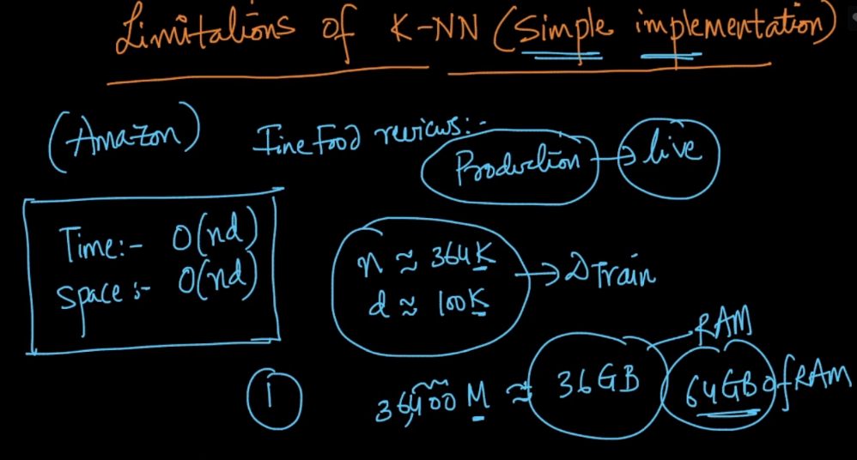

**2) Space Complexity:**

It’s time complexity is also O(n*d), therefore it would take too time in determining the class the input point given in real time production model. Which is not tolerable as if the model is used in:

internet companies like amazon no customer will wait for seconds(5-10), they want output in fewer time(milli or nano seconds)

For Finance system like trading the result should come even in less time.

But if it’s a medical system it’s ok even if it takes 1 min, because a patient can wait for test results.

Such systems which generates results in fewer time are called **low latency**, since latency means time it takes from given an input to generating an output.

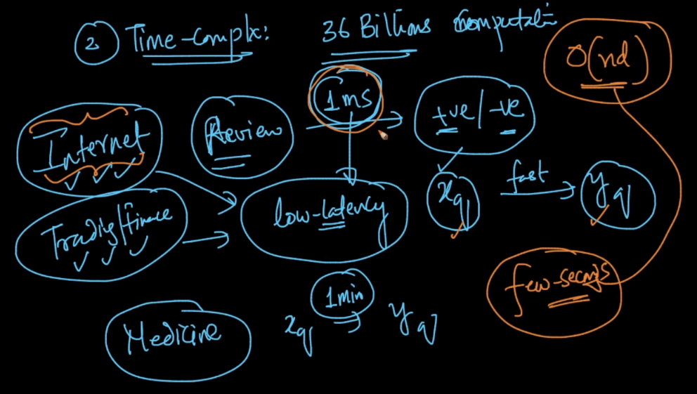

There are some techniques like kd-tree and LSH which can increase k-NN performance.

